Midterm Practice Problems

1. Assume that all nodes have “store and forward” capability.
   1. If each dataset was 1 terabyte (1012 bytes) how long would it take for all of the data to arrive at the processing site if each link was 1 Gigabit/second?
   2. How long would it take for 10 Gigabits/second?
   3. What kinds of delay can you calculate based on the data you have?
2. Suppose you decided to instead send 1 TB flash cards via overnight mail (5pm drop off, delivered by 10am the next day) from each location directly to the destination?
   1. 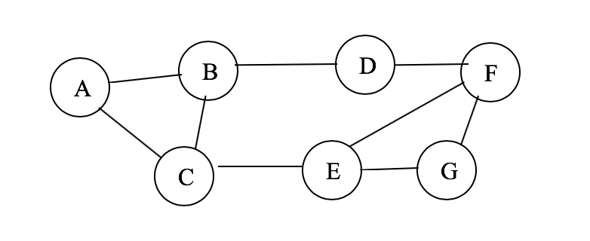How does this change in the communication strategy change the connectivity graph (draw a picure)?
   2. What is the bit rate of each of these channels?
3. 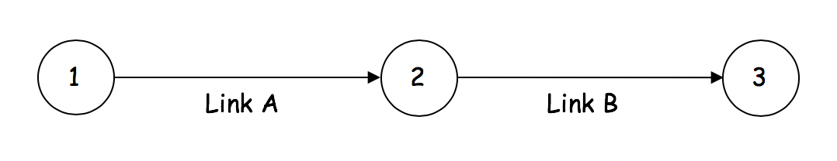Consider the following system:

The attributes of this system are as follows:

**Link A** Bit rate = 2.0 megabits/sec

Length = 240 km

Propagation velocity = 0.8 * speed of light (3*105 km/sec)

**Link B** Bit rate = 1.5 megabits/sec

Length = 135 km

Propagation velocity = 0.9 * speed of light

Node 1 generates messages that are 1 kilobit long.

Node 2 is a relay that does not alter the packets, but only buffers them as needed for retransmission to Node 3.

1. What is the maximum packet transmission rate that Node 1 can have before the system begins to fail?
2. If Node 1 uses a sliding window flow control on Link A, what would the maximum window size be for the system not to fail?